Answer of worksheets

Work sheet ( 1 )
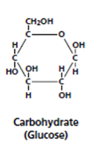
1-C₆ H₁₂ O₆
2-

3-

4-
a-glucose
b-fructose
c-galactose
5-Beta glucose ,alpha glucose
Activity 2:I- Complete the following statements
1-Monosaccharides ( glucose )
2-Monosaccharides
3-Trioses , hexoses
4-Monosaccharides ( glucose )
II-Write the scientific term for
1-Monosaccharides (glucose)
2-Glucose 3-Monosaccharide
ACTIVITY 3:I- Complete the following statements
1-Glycosidic bond
2-Monosaccharides ( glucose )
3-Monosaccharides
4- Starch
II-Write true or false
1-True
2- True
3-False

WORKSHEET 2

Complete the following statements
1-Monosaccharides , disaccharides , polysaccharides
2-Glucose ,fructose , galactose
3- Glycosidic bond
Choose the correct answer
1-a- Hydrophobic
2- b – starch

WORKSHEET 3

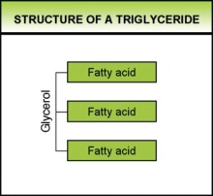
ACTIVITY 1: 1- C₃H₈O₃
2-

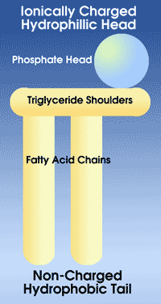
3-Triglycerides are formed of one molecule of glycerol and three molecules of fatty acids
4-

5-Phospholipids are formed of one molecule of glycerol , one molecule of phosphate group and two molecules of fatty acids
6-Triglycerides
ACTIVITY 2:I- Complete the following statements
a-fats , oils
b-solid , oils are liquids
c-glycerol
d-glycerol ,phosphate group , fatty acids
e-triglycerides ,phospholipids
II-Choose the correct answer
- Glycerol
- Oils
- Fats

WORKSHEET 4
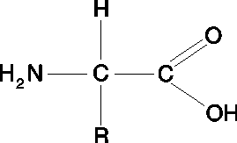
Activity 1
- 2-

H

Activity 2 : I-Complete the following statements
- Amino acids
- Amphoteric
- Peptide bond
- The primary structure of proteins
- Structural
- Enzymes
- Write the scientific term for
- Peptide bond
- Amino acids
3-Choose the correct answer
a-Peptide bond
b-amino acids

WORKSHEET 5

Activity 1:
- Like the previous sheet.
2-Complete the following
a-Primary structure
b-Hydrogen bond , secondary structure
c-Tertiary structure
d-Oxygen , oxyhaemoglobin

3-Choose the correct answer
a-Secondary structure b- Primary structure

